Title: | Window Lifter Module  Design Specification Document

History
Issue status  (Index) | Maturity/Date  (draft/invalid/valid)  (dd-mmm-yyyy) | Author  Department | Check/Release  Department | Description
1.0 | Draft  24-0ct-17 | Jorge Acevedo | Jorge Acevedo | Filled the general information of the document, purpose, and realization constrains and Targets.
2.0 | Draft  25-Oct-17 | Jorge Acevedo | Jorge Acevedo | Conceptual design(Electric Diagram and layers’ connection)
3.0 | Draft  25-Oct-2017 | José Antonio | José Antonio | Conceptual design(Functional Diagram)
4.0 | Draft  26-Oct-2017 | José Antonio | José Antonio | Functions decomposition from the GPIO and PORTS headers at the MCAL layer
4.0 | Draft  26-Oct-2017 | Jorge Acevedo | Jorge Acevedo | SW Component Internal Breakdown (Functional Decomposition), definition, abbreviations and references.
6.0 | Draft  27-Oct-2017 | José Antonio | José Antonio | Functions decomposition from the LPIT header at the MCAL layer
7.0 | Draft  27-Oct-2017 | José Antonio | José Antonio | Functions decomposition from the InitPORT and InitClock headers at the HAL layer
8.0 | Draft  28-Oct-2017 | Jorge Acevedo | Jorge Acevedo | Functions decomposition from the ControlPin and DisableWDOG headers at the HAL layer
9.0 | Draft  28-Oct-2017 | Jorge Acevedo | Jorge Acevedo | Functions decomposition from the initLPIT at the HAL layer
10.0 | Draft  29-Oct-2017 | José Antonio | José Antonio | Functions decomposition from the ReadPin header at the HAL layer
11.0 | Draft  29-Oct-2017 | José Antonio | José Antonio | Functions decomposition from the WindowControl header at the APP layer
12.0 | Draft  01-Nov-2017 | Jorge Acevedo | Jorge Acevedo | Modification of the Physical Architecture Diagram, Erasing the References that are not valid to the project, adding new functions to the Software Internal Component Breakdown
13.0 | Draft  02-11-2017 | José Antonio | José Antonio | Physical Functional Diagram added. With the hardware connections and general description
14.0 | Draft  02-Nov-2017 | Jorge Acevedo | Jorge Acevedo | Definition of the HAL function ReadLPITTimmerFLag, and the APP functions WindowDown, Window Up and AntiPinch the SW Component internal BreakDown.
15.0 | Draft  02-Nov-2017 | Jorge Acevedo | Jorge Acevedo | Addition of the Diagrams for WindowDown, Window Up and AntiPinch in the SW Component internal BreakDown.  Addition of the modified Physical Architecture Diagram.
16.0 | Draft  02-Nov-2017 | José Antonio | José Antonio | Addition of the functions ResetLPITTimerFlag in the HAL layer, and the ModuleInitialization and ModuleStartConditions functions in the APP layer.
17.0 | Draft  26-Nov-17 | José Antonio | José Antonio | Functional graph added.
18.0 | Draft  26-Nov-17 | Jorge Acevedo | Jorge Acevedo | Functional Decomposition. Addition of the Block Diagrams of the BPS and the FSM of the functionalities of the Window Lifter
19.0 | Draft  26-Nov-17 | José Antonio | José Antonio | Physical Architecture. Addition of the Functional decomposition and dynamic behavior.

Table of Contents
1 Purpose 4
2 Definitions and abbreviations 4
3 Realization constraints and targets 6
4 SW Conceptual design 7
4.1 Functional Architecture Diagram 7
4.2 Electric Diagram. 9
4.3 Physical Architecture Diagram 10
5 SW Component internal breakdown 10
5.1 Functional Decomposition 10
5.1.1 Functional Decomposition of the Scheduler 10
5.1.2 Functional Decomposition of the FSM of the Window Lifter Project Functionalities 12
5.2 Function Description and Dynamic Behavior 13
5.2.1 Asw Folder 13
5.2.2 RTE Folder 13
5.2.3 Bsw Folder 21

Purpose
Develop the design of the SW for a Window Lifter module based on the client requirements and using the V development work method. The development follows the Hungarian Name convention and uses Tortoise for uploading the documentation and code files to GitHub Repositories for managing version control.

Definitions and abbreviations
Definitions
T_UWORD | Typedef unsigned short
T_ULONG | Typedef unsigned long
T_SBYTE | Typedef signed char
T_SWORD | Typedef signed short
T_SLONG | Typedef signed long
T_UBYTE | Typedef unsigned char
luw_CounterTimeValidation | Counter used to store one milliseconds cycles to validate and start OneTouch/Manual Function of the module.
lub_LEDBarStatus | Variable used to store the number of LEDs that are turned on, in order to be read by the module and evaluate which LED has to be turned ON/OFF next in the process.
luw_Process | Counter that store the number of milliseconds between transitions, it is initialized to cero every time a PIN logic is toggled and counts to 400 msec to toggle the next one.
lub_AntiPinchBloq | Variable which only values can be 0 or 1, it is used to "block" the AntiPinch Function. A value of one means the AntiPinch has been activated and therefore the module cannot receive any other signal until the AntiPinch function is completed and this value reset.
lub_FOTU | Variable which value means the OneTouch function activation. A one on this variable means the activation of the OneTouch function on the upward direction. It is reset once the manual function is reached, when the module detects the AntiPinch signal and when the DOWN button is pressed.
lub_FOTD | Like the previous one, this variable stores the activation of the OneTouch function but on the downward direction, reset when the Manual function is reached or the UP button is pressed.
luw_CounterAntiPinch | This variable stores the cycles the AntiPinch button is pressed, in order to validate the correct pressing and once the 10 cycles are reached, it continues to store the time between transitions until the window is totally open. Once reached this limit, it counts the 5secs on which the module ignores any instructions. It is reset once the AntiPinch function, including the 5secs "block", is completed.

Abbreviations
ButtonUp | Physical Button that activates the Window’s Crystal upward movement.
ButtonDown | Physical Button that activates the Window’s Crystal downward movement.
ButtonAntiPinch | Safety functionality of the module. It consist in fully open the Window and deactivate its functions for 5 seconds when an interference with the upward movement of the window crystal is detected
HIGH | A 5 Volt signal. Also referred as 1.
LOW | A 0 Volt signal. Also referred as 0.
MHz | Mega Hertz. Measurement of oscillations per unit of time. (1/microsecond)
msec  SPLL | Millisecond. (1/1000 seconds).  System Phase Locked Loop
SOSC | System Clock Source.
RCCR | Run Clock Control Register
PIN | Physical element for electronic connections.
WDOG | Watch Dog Clock.
LED movement indicators | It refers to the LEDs that are turned on when the Window’s Crystal is moving upwards or downwards. A green LED indicates the downward movement and a blue LED indicates an upward movement.
SW | Software.
LED Bar | Bar of LEDs where the Window Crystal movements are emulated. It contains 10 LED and they are named as LED10,LED9,LED8,LED7,LED6,LED5,LED4,LED3,LED2 & LED1.
PTR | Pointer
LED | Light-Emitting Diode
BlueLED | LED moving indicator present in the NXP s32k144 that turns on with inverse logic. This LED indicates the upward movement of the Window’s Crystal.
GreenLED | LED moving indicator present in the NXP s32k144 that turns on with inverse logic. This LED indicates the downward movement of the Window’s Crystal.
LPIT | Low Power Interrupt Timer
GPIO | General Purpose Input/Output
PORT | Terminal connecting an electrical circuit to a device.
PCC | Peripheral Port Controller
SCG | System Clock Generator
PDDR | Port Data Direction Register
PSOR | Port Set Output Register
PCOR | Port Clear Output Register
PTOR | Port Toggle Output Register
PDIR | Port Data Input Register
PCR | Pin Control Register
MCR | Module Control Register
TVAL | Timer Value Register
TCTRL | Timer Control Register
CSR | Control Status Register
BPS | Binary Progression Scheduler
FSM | Finite State Machine
References
N° | Document name | Reference
1 | Window Lifter Requirements version 1 | https://github.com/JorgeAcevedo/CodeWLAntonio_Jorge.git
2 | Traceability Matrix Template | https://github.com/JorgeAcevedo/CodeWLAntonio_Jorge.git
3 | OMG SysML v.1.3 [June 2012] | http://www.sysml.org/docs/specs/OMGSysML-v1.3-12-06-02.zip

Realization constraints and targets

A Window Lifter Module will be developed on an S32k144 NXP’s microcontroller. This module will simulate the up and down movement of the window’s crystal of an automobile on a 10 LED red bar. The module has 3 push buttons as inputs and the signals produced form this buttons shall be validated for interact with the module. It should has an automatic completely open and completely close function and a safety anti pinch function that opens the window’s crystal completely and freeze the module for 5 second before it comes back to its normal working state.

The constrains present in the requirements of the project are:

- The emulation of the Window’s Crystal must be implemented on a 10 LED red bar.
- The transition between the LEDs in the LED bar that represent the movement of the window shall last 400mseconds.
- There must be 3 buttons for interacting with the module. One button for indicating upward movement to the Window’s Crystal, other for indicating the downward movement to the Window’s Crystal and a las one for indicating the activation of the safety function Anti Pinch.
- Each button generated signal must be validated lasting more than 10msec.
- An automatic movement of the Window Crystal shall be implemented.
- The automatic movement of the Window Crystal is activated when the button that moves the Window’s Crystal upwards or downwards movement is pressed for less than 500msec. This automatic mode will lead the Window’s Crystal o its upper or lower limit.
- An Anti Pinch function must be implemented in the module and activated when a button is pressed and the Window’s Crystal is moving upwards.
- The Anti Pinch function moves the Window’s Crystal to its lower limit and keep the Crystal there until 5 seconds have elapsed. Later on it will react again to the buttons.
- A Green LED must be turned on when the Window’s Crystal is moving downwards.
- A Blue LED must be turned on when the Window’s Crystal is moving upwards.
- The code in the Window Lifter Project must contain at least one Finite State Machine (FSM) model implemented.
- A Binary Progression Scheduler shall control de execution of the periodic tasks in the Window Lifter Project. In case that more than one FSM is implemented for the project, each one will be executed on the times that the BPS determine.

SW Conceptual design

Functional Architecture Diagram
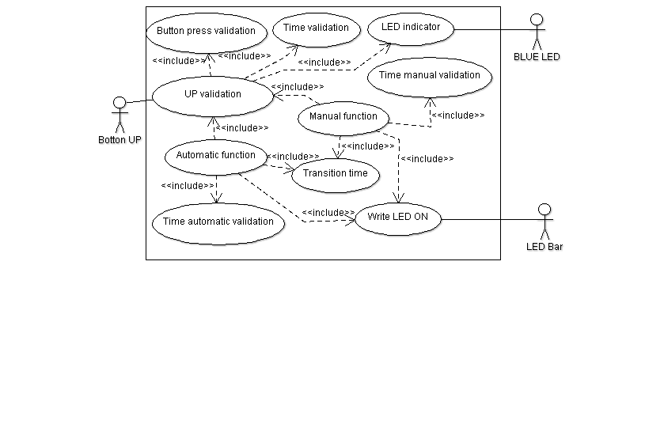
- The time between each transition shall be 400 msec.
- The movement of the window has to be simulated turning on/off the LEDS creating the animation of the window movement.
- In order to consider a validate button press; the button has to be pressed at least 10 msec.
- If a valid UP button is pressed less than 500msecs the window shall UP until get totally CLOSED automatically.
- If a valid UP button is pressed more than 500msecs the window shall UP until get totally CLOSED while the button keep press.

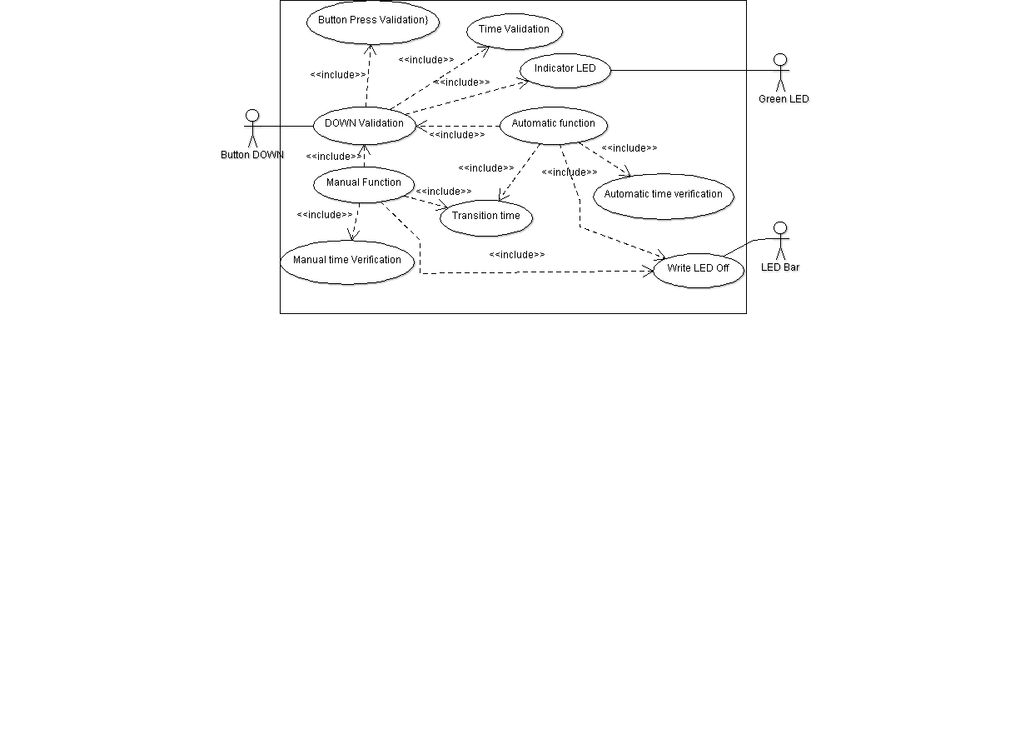
- The time between each transition shall be 400 msec.
- The movement of the window has to be simulated turning on/off the LEDS creating the animation of the window movement.
- In order to consider a validate button press; the button has to be pressed at least 10 msec.
- If a valid DOWN button is pressed less than 500msecs the window shall DOWN until get totally OPEN automatically.
- If a valid DOWN button is pressed more than 500msecs the window shall DOWN until get totally OPEN while the button keep press.

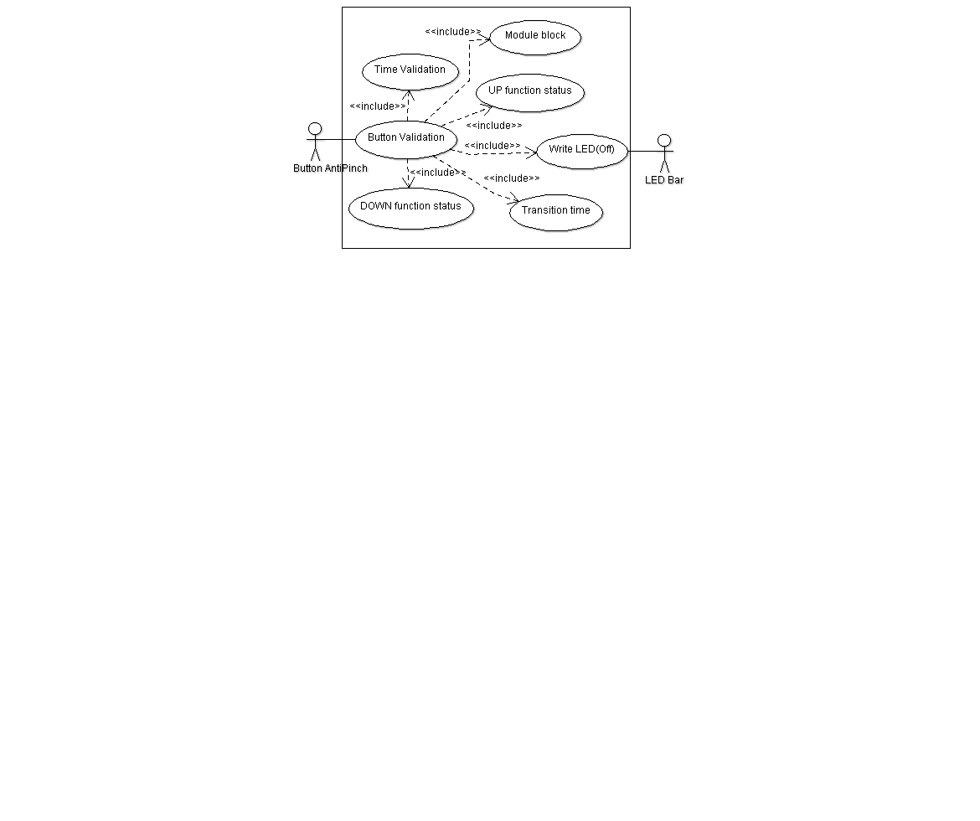
- The signal than indicates to the module the detection of a pinch will be a push button.
- Anti pinch button press has to follow the same characteristics than UP and DOWN buttons for valid press.
- The AntiPinch signal just can be considered as valid when the movement is UP.
- If this signal is valid then the module has to stop the UP Movement and then DOWN the window until the window get totally OPEN.
- After window is totally OPEN the module has to ignore during 5 seconds all button press.

Electric Diagram.

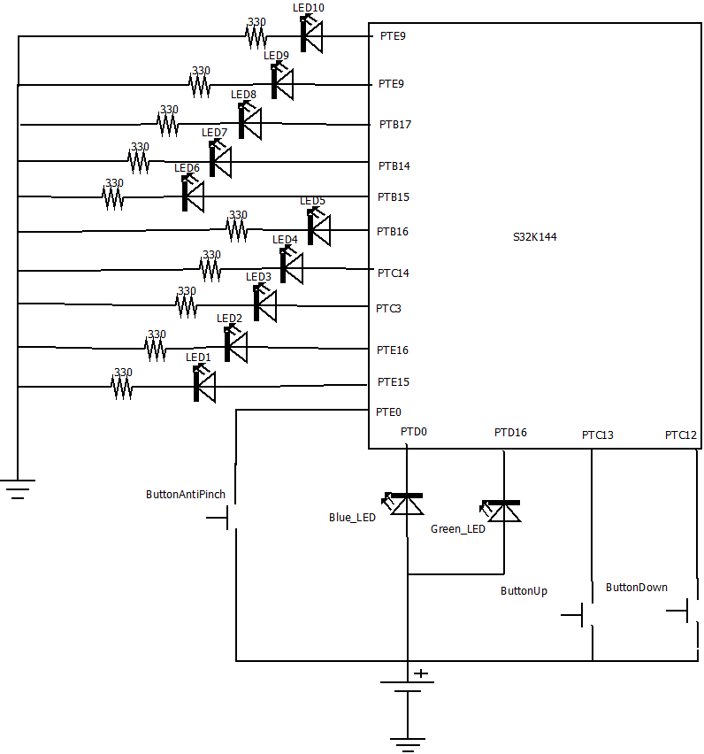

Physical Architecture Diagram
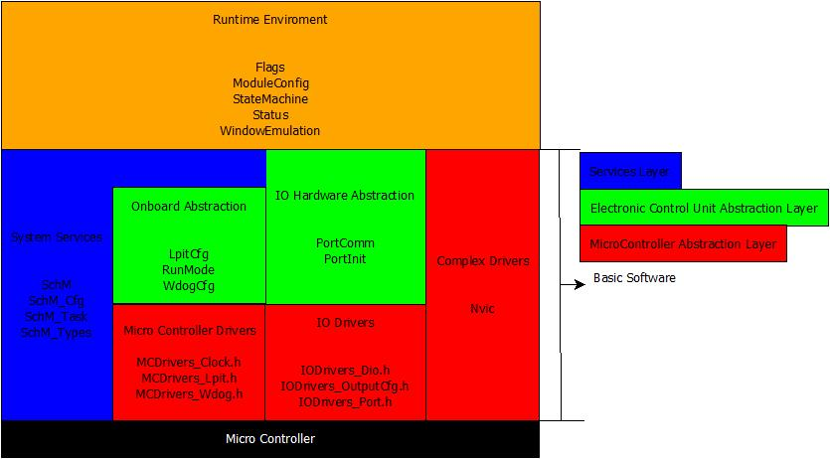

SW Component internal breakdown

Functional Decomposition

Functional Decomposition of the Scheduler

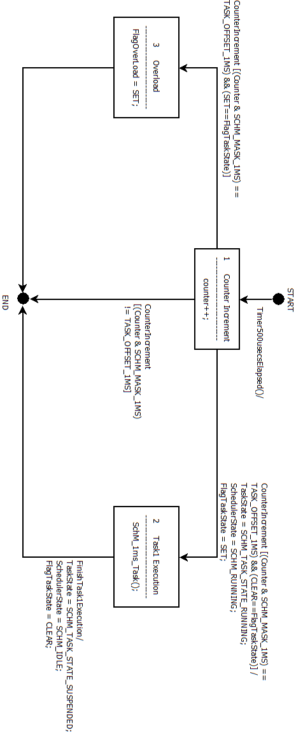

Functional Decomposition of the FSM of the Window Lifter Project Functionalities
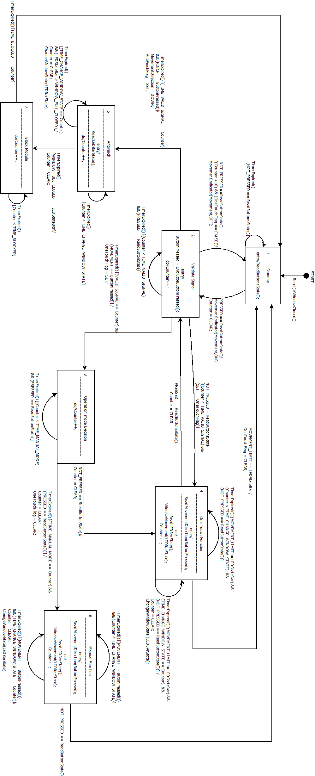

Function Description and Dynamic Behavior

Asw Folder

Entry

int main (void)

Description | Main function to start conditions, clocks and resources for the application to be executed
Void  Input | This function does not receive any value
Return Value | This function returns an integer to make sure the module never stops executing, since the return sentence should never be reached
Precondition | The main function only communicates with the Runtime Environment Layer
Post condition
Error conditions

Dynamic Behavior
- First, the main function start the module resources and establish inputs/output for the application(s).
- The interrupts are enabled to make use of the scheduler and have a best time control.
- The scheduler is then initialized with the periodic tasks needed.
- Finally, the application(s) are started one by one according with their priority.

RTE Folder

Flags

void SetOneTouchFlag (VariablesType *Variables)
Description | This function entry at action to indicate the module that the OneTouch function is enable.
VariablesType *Variables  Input | The VariablesType structure stores all the concerning values to control the Window Lifter. And it is used on all the functions that need to read the current values of any register or write on them.
Return Value | This function does not return any value
Precondition | For this function to be called, a movement (UP or DOWN) button press shall be validated
Post condition | Once this function is executed, the Flag is settled to enter the OneTouch function in case that the button is not pressed anymore and the flag is not cleared.
Error conditions

void ClearOneTouchFlag (VariablesType *Variables)
Description | This function entry at action to indicate the module that the OneTouch function is disable.
VariablesType *Variables  Input | The VariablesType structure stores all the concerning values to control the Window Lifter. And it is used on all the functions that need to read the current values of any register or write on them.
Return Value | This function does not return any value
Precondition | For this function to be called, a movement (UP or DOWN) button press shall be pressed for at least 500 msecs to enter the Manual Function or at least 10 msecs during the OneTouch Function to indicate the module that it needs to stop.
Post condition | Once this function is executed, the Flag is settled to exit the current OneTouch function or in case the Manual function is executed.
Error conditions

void SetAntiPinchBlock (VariablesType *Variables)
Description | This function entry at action to indicate the module that the AntiPinch function shall be executed
VariablesType *Variables  Input | The VariablesType structure stores all the concerning values to control the Window Lifter. And it is used on all the functions that need to read the current values of any register or write on them.
Return Value | This function does not return any value
Precondition | For this function to be called, the press of the AntiPinch button during the UP movement need to be verified (e.g. pressed for at least 10 msecs)
Post condition | Once this function is executed, the AntiPinch block is settled and executes the code without considering any other indications.
Error conditions

void ClearAntiPinchBlock (VariablesType *Variables)
Description | This function entry at action to indicate the module that the AntiPinch block is over and the module can be used again.
VariablesType *Variables  Input | The VariablesType structure stores all the concerning values to control the Window Lifter. And it is used on all the functions that need to read the current values of any register or write on them.
Return Value | This function does not return any value
Precondition | For this function to be called, the AntiPinch function shall be completed and 5 secs need to have passed to disable the module blocking.
Post condition | Once this function is executed, the module can be used normally.
Error conditions

ModuleConfig

Void NormalModeModuleInit (void)
Description | This function starts the resources and set the input/output ports to use during the application.
void  Input | This function does not receive any value.
Return Value | This function does not return any value
Precondition
Post condition | The module resources are ready to be used
Error conditions

Dynamic Behavior
- The Watch Dog clock is disabled to avoid malfunction of the module.
- The ports are initialized as input or output depending on the application and write with the initial logic for the start conditions.
- The micro controller clocks that are going to be used are started and configured to run at the proper speed. In this case, the application makes use of the normal run mode.

Void EnableInterruptions (void)
Description | This function configure the interruptions to be used and their priorities.
void  Input | This function does not receive any value.
Return Value | This function does not return any value
Precondition
Post condition | The module’s interruptions are settled to be used
Error conditions

Void SchedulerInit (void)
Description | Initialize the scheduler with the proper conditions, as timers, masks, and interruptions functions
void  Input | This function does not receive any value.
Return Value | This function does not return any value
Precondition
Post condition | The scheduler is ready to work as soon it receives the timer signal.
Error conditions

Void WindowLifterApp (void)
Description | This is the main function to work with the Window Lifter and it is the last function that shall be reached at this file.
void  Input | This function does not receive any value.
Return Value | This function does not return any value
Precondition
Post condition | Starts the timer and the Window Lifter application with all its requirements.
Error conditions

StateMachine

Void StateMachine (VariablesType *Variables)
Description | This function is the Window Lifter itself and decides the different states to be executed at any given time.
VariablesType *Variables  Input | The VariablesType structure stores all the concerning values to control the Window Lifter. And it is used on all the functions that need to read the current values of any register or write on them.
Return Value | This function does not return any value
Precondition | For this function to be called, the State need to be already decided because it is a switch-case execution that receive that state.
Post condition | Once this function is executed, the module can be used normally.
Error conditions

Dynamic behavior
This function is sufficient complex to need a diagram to be properly explained but, since the function of the window lifter is indicated at section 5.1.2, it would be redundant to add it here.

Status

T_UBYTE ButtonPress (T_UBYTE UPDOWNPINCH)
Description | Encloses all the possible buttons press in order to make easier to determinate which button is evaluating.
T_UBYTE UPDOWNPINCH  Input | It is a single word (UP, DOWN or PINCH) that indicates which button should be evaluated.
Return Value | T_UBYTE. TRUE, in case the button is pressed or FALSE otherwise.
Precondition
Post condition | The module knows that the button is pressed and can act as consequence of it.
Error conditions

Void ReadButtonStatus (VariablesType *Variables)
Description | Decides the current status of the module based of the button that is pressed at a given time
VariablesType *Variables  Input | The VariablesType structure stores all the concerning values to control the Window Lifter. And it is used on all the functions that need to read the current values of any register or write on them.
Return Value | This function does not return any value
Precondition
Post condition | The Window Lifter application status change to movement or pinch, depending of the result of this function. Also, on the first case, the movement direction is also settled.
Error conditions
Dynamic Behavior
- Detects if any button is pressed in priority order. In case one with higher priority is pressed, then ignores the next one. The priority order is DOWN, PINCH, UP.
- If detects the press of the DOWN button, sets the movement direction as DOWN and the status as MOVEMENT.
- If detects the press of the PINCH button, sets the status as PINCH.
- If detects the press of the UP button, sets the movement direction as UP and the status as MOVEMENT.
- If the functions does not detect any button pressed, the status is settled as NONE.

Void StateDecision (VariablesType *Variables)
Description | Decides the current state of the module to be executed for the State Machine.
VariablesType *Variables  Input | The VariablesType structure stores all the concerning values to control the Window Lifter. And it is used on all the functions that need to read the current values of any register or write on them.
Return Value | This function does not return any value
Precondition | The current status shall be known by the time the decision needs to be taken.
Post condition | The State that will be executed by the State Machine is determinate.
Error conditions
Dynamic Behavior
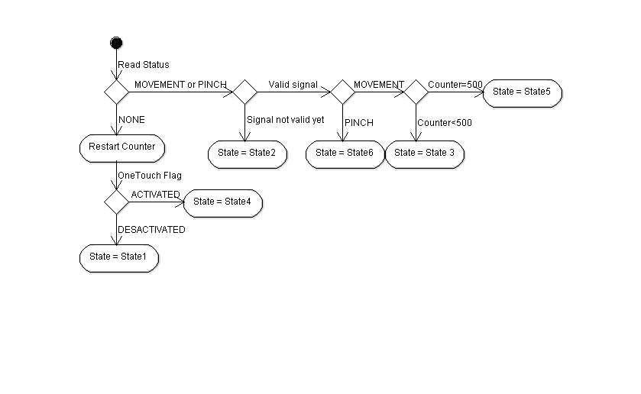

WindowEmulation

Void WindowEmulator (VariablesType *Variables)
Description | Responsible to assure that the transitions to OPEN/CLOSE the window are 400 msecs apart.
VariablesType *Variables  Input | The VariablesType structure stores all the concerning values to control the Window Lifter. And it is used on all the functions that need to read the current values of any register or write on them.
Return Value | This function does not return any value
Precondition
Post condition
Error conditions

Dynamic Behavior
- In case the counter is at the zero value, the function simulate the window and increase the counter by one.
- When the counter is neither at zero nor at the transition value (400), the counter increases by one.
- Once the counter have reached the transition value, it resets the counter in order to simulate the window by the next cycle.

Void WindowSimulation (VariablesType *Variables)
Description | Responsible to call the function to turn ON/OFF the LEDs and update the state of the LED Bar according with the movement direction.
VariablesType *Variables  Input | The VariablesType structure stores all the concerning values to control the Window Lifter. And it is used on all the functions that need to read the current values of any register or write on them.
Return Value | This function does not return any value.
Precondition | The movement direction needs to be known prior to call this function.
Post condition | The next LED on the bar will be turned ON/OFF and LEDBarState variable will decrease or increase by one, depending of the movement.
Error conditions

Dynamic Behavior
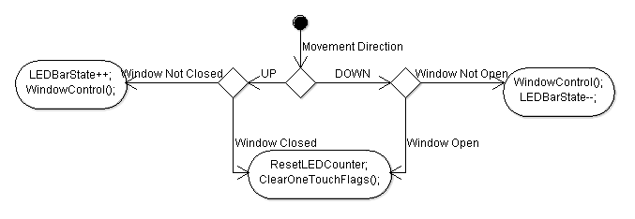

Void TurnOnIndicator (VariablesType *Variables)
Description | Turn On the LED to indicate whether the button UP or DOWN is valid and the corresponding movement is in progress.
VariablesType *Variables  Input | The VariablesType structure stores all the concerning values to control the Window Lifter. And it is used on all the functions that need to read the current values of any register or write on them.
Return Value | This function does not return any value.
Precondition | The movement direction needs to be known prior to call this function.
Post condition | The indicator LED (blue for UP and green for DOWN) is turned ON to indicate its correct validation.
Error conditions

Void TurnOffIndicator (VariablesType *Variables)
Description | Turn Off the LED to indicate that the corresponding function associated with button UP and DOWN is no longer in progress.
VariablesType *Variables  Input | The VariablesType structure stores all the concerning values to control the Window Lifter. And it is used on all the functions that need to read the current values of any register or write on them.
Return Value | This function does not return any value.
Precondition
Post condition | The indicator LED (blue for UP and green for DOWN) is turned OFF to indicate the corresponding function termination.
Error conditions

Dynamic behavior
- To be used no matter which the direction is and avoid both LEDs to be turned ON during certain states, this function turn OFF both indicators.

Void WindowControl (VariablesType *Variables)
Description | Toggle the corresponding pin according with the current LEDBarState value.
VariablesType *Variables  Input | The VariablesType structure stores all the concerning values to control the Window Lifter. And it is used on all the functions that need to read the current values of any register or write on them.
Return Value | This function does not return any value.
Precondition
Post condition | The corresponding pin of LEDBarState is toggle to simulate the opening/closing of the window
Error conditions

Bsw Folder

ECU Folder

IOHAs Folder

PortComm

Void Dio_PortSetPin (DioPortType DioPort, uint32_t DioPin)
Description | Write the logic value “1” to the selected pin.
DioPortType DioPort  Input | The DioPortType stores the different module´s ports (A,B,C,D or E) to select on which one is the pin that We want to set at logic “1”
Uint32_t DioPin  Input | This value determinates which pin of the corresponding port is going to be settled to logic “1”
Return Value | This function does not return any value.
Precondition
Post condition | The corresponding pin is settled to logic value “1”
Error conditions

Void Dio_PortClearPin (DioPortType DioPort, uint32_t DioPin)
Description | Write the logic value “0” to the selected pin.
DioPortType DioPort  Input | The DioPortType stores the different module´s ports (A,B,C,D or E) to select on which one is the pin that We want to set at logic “0”
Uint32_t DioPin  Input | This value determinates which pin of the corresponding port is going to be settled to logic “0”
Return Value | This function does not return any value.
Precondition
Post condition | The corresponding pin is settled to logic value “0”
Error conditions

Void Dio_PortTooglePin (DioPortType DioPort, uint32_t DioPin)
Description | Change the current logic to the opposite one.
DioPortType DioPort  Input | The DioPortType stores the different module´s ports (A,B,C,D or E) to select on which one is the pin that We want to change logic value.
Uint32_t DioPin  Input | This value determinates which pin of the corresponding port is going to be settled to the contrary logic.
Return Value | This function does not return any value.
Precondition
Post condition | The corresponding pin´s value is changed.
Error conditions

T_UBYTE Dio_PortGetPin (DioPortType DioPort, uint32_t DioPin)
Description | Reads the current logic write at the corresponding pin.
DioPortType DioPort  Input | The DioPortType stores the different module´s ports (A,B,C,D or E) to select on which one is the pin that We want to know its value.
Uint32_t DioPin  Input | This value determinates which pin of the corresponding port is going to be read.
Return Value | Returns a single flag (TRUE) if the pin logic is “1”, FALSE otherwise.
Precondition
Post condition | The corresponding pin´s value is changed.
Error conditions

PortInit

Void PORT_init (void)
Description | Starts the clock source for the ports that are going to be use. Also, the pins are settled as INPUT/OUTPUT depending our wishes. Finally, the corresponding pin is settled or cleared according with our starting conditions.
Void  Input | This function does not receive any value.
Return Value | This function does not return any value.
Precondition
Post condition | All the ports that are going to be used are initialized.
Error conditions

OBAs Folder

LpitCfg

Void LPIT0_init (tCallbackFunction Pit0Callback)
Description | Configures and gets all settled to use the LPIT channel 0 timer.
tCallbackFunction Pit0Callback  Input | This function receive a pointer to a function, to be executed during the interruption.
Return Value | This function does not return any value.
Precondition
Post condition | The counter configuration is ready to be used. With the proper clock source and the correct counter value.
Error conditions

Void LPIT0_Start (void)
Description | Enable the timer channel
Void  Input | This function does not receive any value.
Return Value | This function does not return any value.
Precondition
Post condition | The timer and counting process is started for the LPIT channel 0
Error conditions

void LPIT0_Stop (void)
Description | Disable the timer channel
Void  Input | This function does not receive any value.
Return Value | This function does not return any value.
Precondition
Post condition | The timer and counting process is stopped for the LPIT channel 0
Error conditions

void LPIT0_Ch0_IRQHandler (void)
Description | This is the function provided for the micro controller producer to be executed at the LPIT0 interruption.
Void  Input | This function does not receive any value.
Return Value | This function does not return any value.
Precondition
Post condition | This function makes use of a pointer to Callback the corresponding function.
Error conditions

RunMode

Void SOSC_init_8MHz (void)
Description | Configures the SOS clock to provide an 8MHz signal to the module
Void  Input | This function does not receive any value.
Return Value | This function does not return any value.
Precondition
Post condition | The source clock is configured and ready to be used for the module.
Error conditions

Dynamic Behavior
- This function configures the division, range and source crystal for the SOS clock.
- Once the clock is ready, the oscillator is enabled.
- Finally, checks the validation of the signal to exit the function with the proper frequency.

Void SPLL_init_160MHz (void)
Description | Starts the function of the system clock provider
Void  Input | This function does not receive any value.
Return Value | This function does not return any value.
Precondition
Post condition | The module´s 160MHz frequency is settled and ready to be used for the module.
Error conditions

Dynamic Behavior
- Disables the SPLL to permit write on the register.
- Configures the division values.
- Configures the SOSC division and multiplication.
- Enable the SPLL to store the changes to work at 160MHz.

Void NormalRUNmode_80MHz (void)
Description | Provides the configuration to works with the module at normal mode
Void  Input | This function does not receive any value.
Return Value | This function does not return any value.
Precondition | The SPLL timer needs to be activated.
Post condition | The proper sources are initialized to any ports and resources.
Error conditions

Dynamic Behavior
- Chooses the PLL as clock source.
- Configures the division for the core, bus and slow mode.
- Wait until the proper source is configured.

WdogCfg

Void WDOG_disable (void)
Description | Disable WDOG to avoid malfunction of the module.
Void  Input | This function does not receive any value.
Return Value | This function does not return any value.
Precondition
Post condition | Watchdog is disabled on the module.
Error conditions

